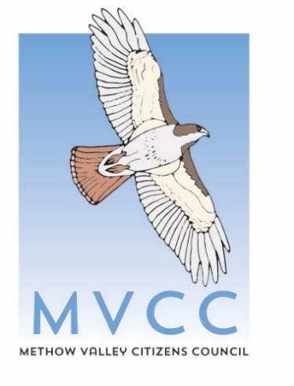
Methow Valley Citizens Council is hiring an Executive Director
Location: Twisp, WA
Salary: $80,000-$90,000
Job posted October 20, 2025; position open until filled; priority given to applications received before November 17, 2025

Methow Valley Citizens Council (MVCC) is at an inflection point. Development pressures are intensifying, demographics are shifting, and the challenges we face—from water allocation to climate adaptation—are more complex than ever. In addition, we have increasingly recognized that these challenges extend beyond the Methow Valley to the greater Okanogan, and our programs are expanding beyond the Methow as well. We need a leader who can honor our fifty-year legacy while boldly guiding us into our next chapter.
We're seeking an Executive Director who will set ambitious goals, lead a talented staff team, further strengthen partnerships and grow coalitions, and serve as a trusted voice in our community. You'll work closely with the Board and Staff to implement MVCC's strategic plan, cultivate relationships with diverse stakeholders, ensure long-term financial sustainability, and position the organization to meet emerging challenges while staying true to our founding values.
This is an opportunity to shape the future of a place where conservation, community, and rural character intersect—where your leadership will directly impact both the landscape and the people of the Methow Valley and greater Okanogan County.
The Executive Director reports to the Board of Directors and is supervised by the Board Chair.

About Methow Valley Citizens Council (MVCC)
Nearly fifty years ago, committed citizens in the Methow Valley formed the Methow Valley Citizens Council to raise their collective voice against the forces that routinely ruin western mountain valleys like this one: uninhibited growth, a lack of planning, and a settler-colonial, resources-first approach that displaces both the natural environment and the memory of cultures that came before. MVCC has become an attentive and tireless advocate working to protect the natural environment and rural character of the Methow.
Over the decades we have played a major role in averting the development of a large ski resort and golf resort in Mazama as well as a copper mine in the headwaters of the Methow River. Today, our work spans four developed program areas: protecting open space, dark skies, and wildlife habitat through land use planning, ensuring our precious water can support future growth and is equitably shared; working to improve our County’s air quality and the health of our most vulnerable residents; and ensuring Okanogan County is prepared for the changes that climate change is bringing to this region by collaboratively implementing the Methow Valley Climate Action Plan. Through our work with local schools, we are facilitating the participation of the next generation of youth climate advocates. In recent years, MVCC has strengthened relationships with tribes in our region, particularly the Confederated Tribes of the Colville Reservation, whose traditional territory encompasses the Methow Valley and all of Okanogan County. Our members are engaged and inspired citizen activists who have always advocated for rural and community values.
For more about the broad suite of issues that we work on, please visit: www.mvcitizens.org.

Essential Responsibilities

Strategic Leadership and Vision
- Work with the Board of Directors and Staff to develop and implement a long-range strategy that ensures that MVCC achieves its mission.
- Provide leadership in developing programmatic, organizational, and financial plans that are consistent with the strategy and will ensure long-term sustainability and impact.
- Working with the Board, determine allocation of staff and financial resources for MVCC programs and major issues in which MVCC is engaged.

Community Engagement and Advocacy
- Serve as a visible community leader and public voice for MVCC, representing the organization in coalition work, public forums, and media engagement as appropriate.
- Build and maintain strong relationships with community partners, elected officials, agency staff, and diverse stakeholders to advance MVCC's mission and expand our impact.
- Maintain a working knowledge of significant developments and trends in the field.
- Build a positive climate and image that emphasizes gratitude, both inside and outside our organization.

Organizational Management
- Lead a team of dedicated, high-performing staff, promoting a collaborative and inclusive work environment.
- Provide staff development, performance evaluation, and retention strategies for staff, contractors, and interns.
- Manage and support MVCC office and program staff in the day-to-day business of the organization.
- Ensure all necessary policies are in place and are followed.

Fundraising and Financial Management
- Lead fundraising efforts, including the identification and cultivation of major donors, grant writing and execution of fundraising campaigns.
- Develop and execute a strategy to build our membership base.
- Work with the Staff and the Board to develop the annual budget and manage the organization’s finances to ensure that the organization operates within that budget.

Skills and Qualifications
- Demonstrated passion for the mission of MVCC.
- At least 3 years of experience in a leadership capacity with a non-profit organization, governmental body, citizen effort, or company.
- Strong organizational and managerial skills with experience fostering a positive and supportive work environment
- Excellent communications skills, both verbal and written
- Strong interpersonal skills and ability to be calm, courteous, and focused even under changing and challenging circumstances
- Ability to make decisions and act confidently with minimal supervision
- Strong work ethic, attention to detail, and ability to complete assignments or negotiate deadlines to address changing priorities and workload
- Experience using and incorporating technology into operations to improve organizational effectiveness and community engagement
- Prior conservation work desirable

Compensation and Work Environment
This is a full-time salaried position based in Twisp, WA. Most work will happen in-person in shared office space; some travel and evening hours will be necessary. The anticipated salary range is $80,000 to $90,000 depending on qualifications and experience. Additional benefits include paid holidays, vacations, and sick leave as well as stipends to cover health care costs and the use of a personal cell phone. In addition, all full-time employees are eligible for a paid sabbatical leave after each five consecutive years of employment.

Resume and Cover Letter
Please send any inquiries, your resume and a cover letter to Nancy Milsteadt at nancy@mvcitizens.org. In your cover letter, please describe how your background, interests and experience are a fit for MVCC’s mission and values as described in this announcement. The position is open until filled.

